Gendered Consumption at Target.com
For this time’s sociology observation, I went back to Target.com, a shopping website I often use. In the past, I noticed color patterns like blue for men and pink for women, but I always thought it was natural and did not think much about it. This time, with a sociological view from class, I realized that gender divisions in products are much more complicated than just color differences.
In the adult deodorant section, Target has categories like “Women’s Deodorant” and “Men’s Deodorant,” and it also has categories by ingredients or functions, such as “Aluminum-Free Deodorant” (Figure 1). Gender is one way the website organizes products, but not the only way. The product pages I looked at all use white backgrounds and red buttons, and there is no separate page design for men’s and women’s products. The differences appear more in product names, packaging, and descriptions.
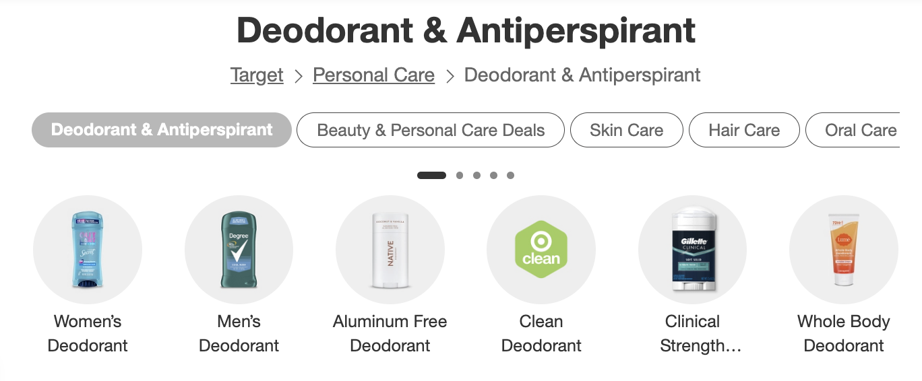
Figure 1. Target’s deodorant categories.
Old Spice is labeled “Men’s Deodorant,” while Secret says “for Women” (Figures 2–3). Before taking a further look at ingredients and effects, the name already tells us which one to choose. Their packaging is not the “blue for men, pink for women” pattern I expected before: Old Spice is red, while Secret is blue.
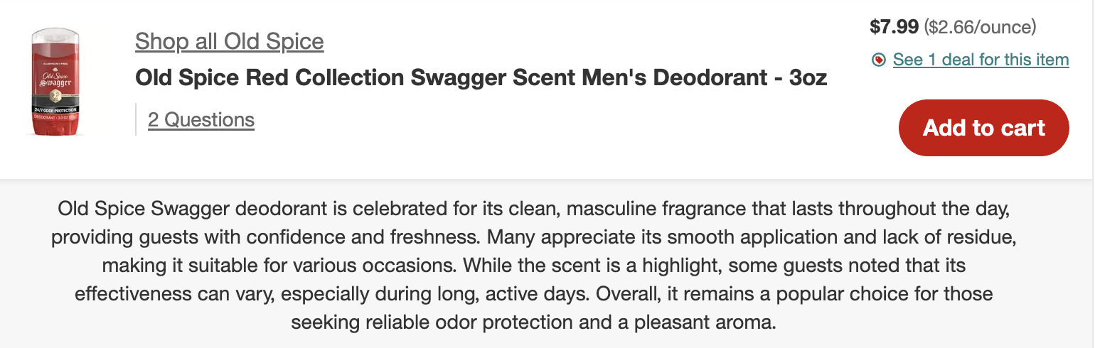
Figure 2. Old Spice men’s deodorant.
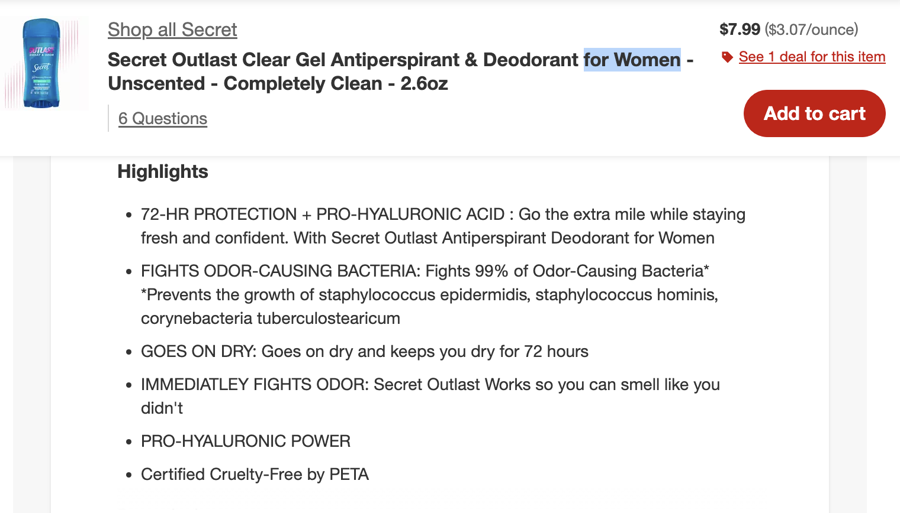
Figure 3. Secret women’s antiperspirant and deodorant.
What is worth noting is the wording. Old Spice’s description connects scent with “masculinity” and “confidence”. With a sociological perspective, I feel it sells not only odor protection, but also a male image. Secret also emphasizes confidence and performance, including “72-HR PROTECTION.” This is not the same as the simple impression that men’s products talk about performance and women’s products talk about being pretty.
How are these labels related to socialization? Becker thinks culture includes shared understandings that people rely on when they coordinate common activities (Becker 1982). When we see “for men” or “for women,” we usually know right away who the product is for. Because we already have these gender ideas in daily life. And. if people see this kind of division again and again, they may get used to choosing by gender first, instead of asking what they actually need. Furthermore, when adults choose products for children, they may also pass this habit down. But labels are only hints, and consumers, of course, do not always follow them.
Native is a good example of another way. It uses white packaging and gold lettering, and it clearly says “for Men & Women” (Figure 4). Its description mainly stresses ingredients, odor protection, and how it feels to use. It’s a body-care product as well, but it does not ask the shopper to pick a gender first. This shows that gender is not the only way to introduce this kind of product. It still mentions gender, but it does not arrange two separate images for men and women. To me, this can be seen as an example, that the boundary between men’s and women’s marketing is becoming a little looser.
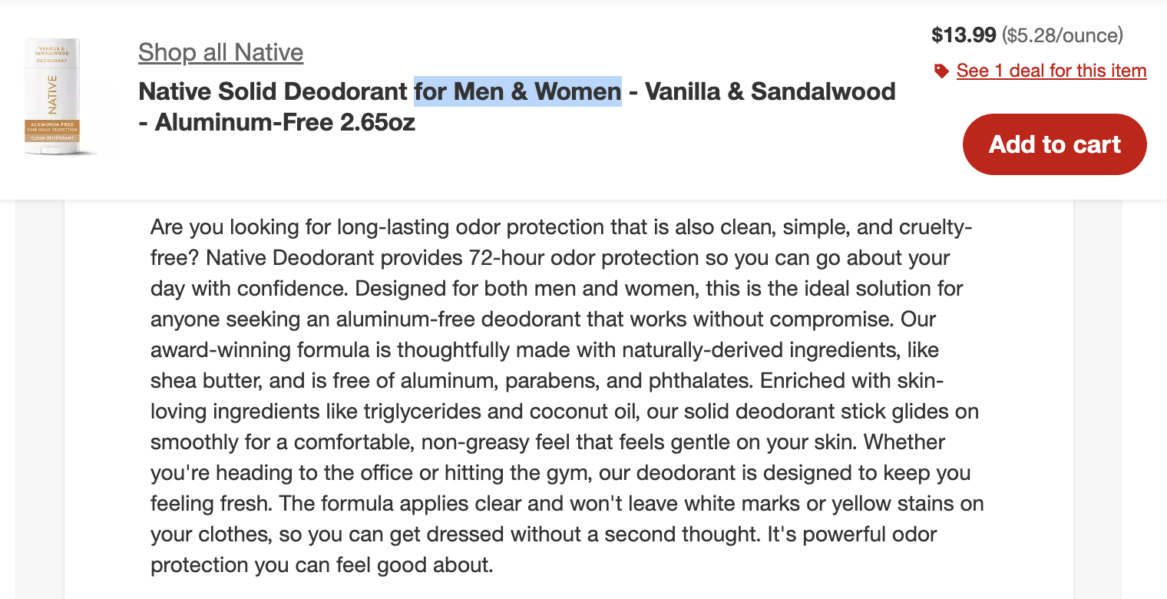
Figure 4. Native deodorant for men and women.
Children’s toys have similar examples. Melissa & Doug’s cleaning set includes a broom, mop, and so on (Figure 5). Its description clearly targets boys and girls, and it describes cleaning as learning independence, responsibility, and life skills. Here, housework is not said to be only a girl’s thing. Kane’s 2006 study found that many parents accept boys learning housework skills and showing care (Kane 2006). This toy makes me feel that products can also encourage children to try activities without first telling them that “this is what boys or girls should do”.
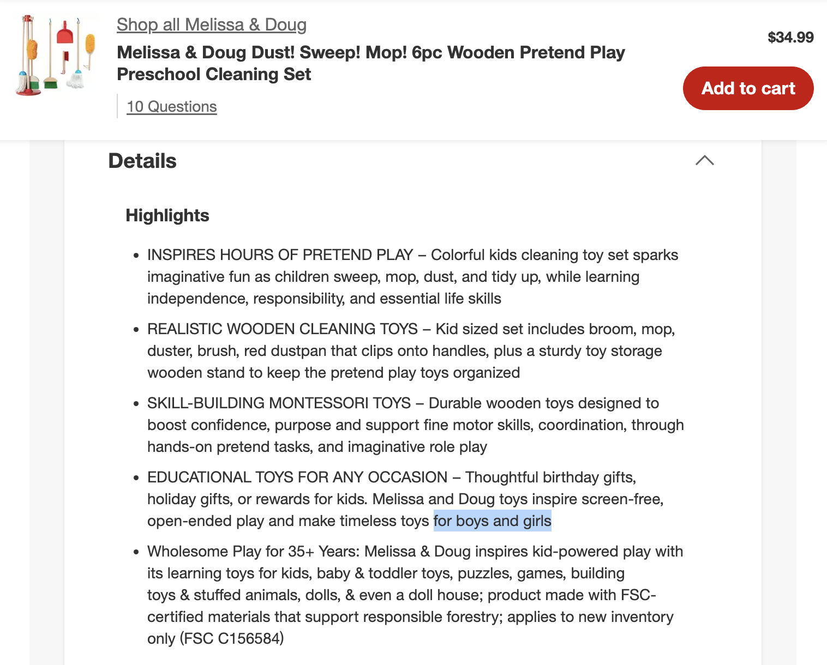
Figure 5. Melissa & Doug cleaning play set.
Looking at Target with a sociological view, I care more than before about how products tell us “who this is for.” The class phrase “Make the familiar strange” became concrete in this observation: before, I chose by men’s and women’s labels; now I stop and think why products are classified this way and what gender expectations they suggest (“What Is Sociology” n.d., slide 14). Finally, I did not observe actual reactions of consumers and children, so I can only analyze the messages products send. I cannot say these messages will definitely affect them in a certain way.

References
Becker, Howard S. 1982. “Culture: A Sociological View.” The Yale Review 71:513–528.
Kane, Emily W. 2006. “‘No Way My Boys Are Going to Be Like That!’: Parents’ Responses to Children’s Gender Nonconformity.” Gender & Society 20(2):149–176.
“What Is Sociology.” n.d. 1.2—What Is Sociology. Course lecture slides, slide 14.
Target. n.d.a. “Old Spice Red Collection Swagger Scent Men’s Deodorant—3oz.” Retrieved September 18, 2026. https://www.target.com/p/-/A-13959207
Target. n.d.b. “Secret Outlast Clear Gel Antiperspirant & Deodorant for Women—Unscented—Completely Clean—2.6oz.” Retrieved September 18, 2026. https://www.target.com/p/-/A-92611655
Target. n.d.c. “Native Solid Deodorant for Men & Women—Vanilla & Sandalwood—Aluminum-Free 2.65oz.” Retrieved September 18, 2026. https://www.target.com/p/-/A-92611691
Target. n.d.d. “Melissa & Doug Dust! Sweep! Mop! 6pc Wooden Pretend Play Preschool Cleaning Set.” Retrieved September 18, 2026. https://www.target.com/p/-/A-51014135
Target. n.d.e. “Deodorant & Antiperspirant.” Retrieved September 18, 2026. https://www.target.com/c/deodorant-personal-care/-/N-5xtzp

