Gendered Consumption at Target.com
Making the Familiar Strange
For this assignment, I took the approach of viewing the shopping site of Target.com as a sociological field site as opposed to a shopping site. I asked myself what role can be played by ordinary categories of consumers, and how can gender become a wider pattern of society, when we used the idea of “making the familiar strange” that we are looking for in the lectures and in discussions about C. Wright Mills's sociological imagination. Observed children's STEM toys and some children's clothing, as well as adult shave products, including category labels, packaging, advertising language and the price.
The first thing I saw was the layout of the Target website. Other products that have similar grooming purposes are divided into “Women's Hair Removal” and “Men's Shaving.” The page design is the same with red and white, and the gender coding does not seem to be as pronounced as that in the page background or as product language. From a symbolic-interactionist point of view, the words are symbols that help shape the meaning shoppers give to their perception of “for women” or “for men.” This is also a social construction, as it is socially organized yet presented as ordinary.
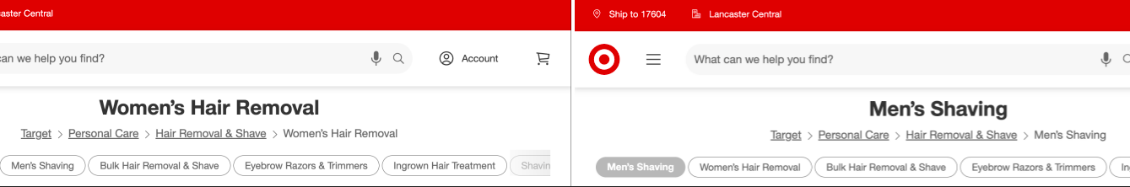
Figure 1. Target separates similar grooming products into “Women’s Hair Removal” and “Men’s Shaving.” Screenshots taken September 8, 2026.
Sources: Women’s Hair Removal | Men’s Shaving
I then made a comparison of two listings for Schick Hydro Sensitive refills. The women’s six-pack was $16.99 ($2.83 each), while the men’s six-pack was $14.99 ($2.50 each). The women's section included the terms“all your curves”and“touchably soft skin”while the men's included the terms “sharpness and durability” and a “close, comfortable shave.”Interestingly, the women's package was not just pink, but turquoise, blue, indicating that the importance of gender coding is not just in the color, but also in the language and positioning. But, there is a difference and mindful skepticism is key: The cartridges are not the same, so this type of comparison can't prove“pink tax”and intentional discrimination. As we've learned in research methods, correlation does not imply causation.
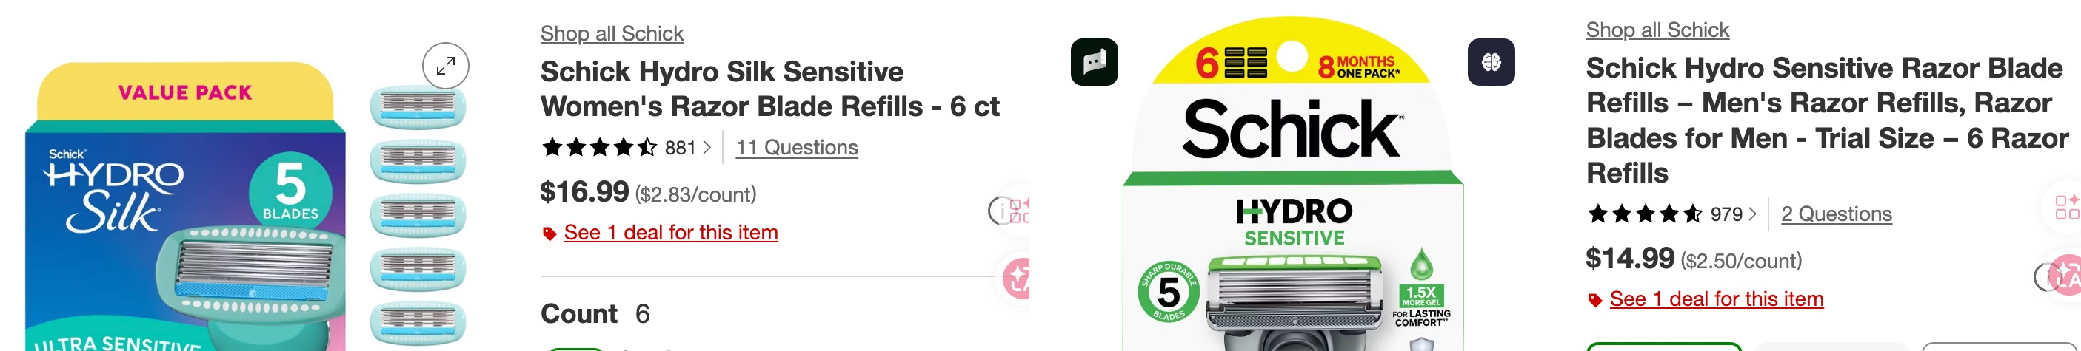
Figure 2. Schick Hydro refill listings: women’s $16.99 ($2.83/count) and men’s $14.99 ($2.50/count), observed September 8, 2026.
Sources: Women’s Schick refill | Men’s Schick refill
The continuity and change in the children's section was evident. A Barbie Chemistry Science & Activity Kit brings chemistry to the traditionally feminine brand. This is interesting because it is a challenge and the reproduction of stereotype at the same time – it broadens the possibilities of what girls may imagine they could do, and it may make science more acceptable in a familiar female identity. Target also has an option for “Gender Neutral Baby Clothing.” Coyle and Liben's experiment with 61 mother-child dyads showed that gendered STEM packaging influenced a child's pattern of play and mechanical learning, indicating that marketing can be a part of socialization that does not have to be the sole cause of it.
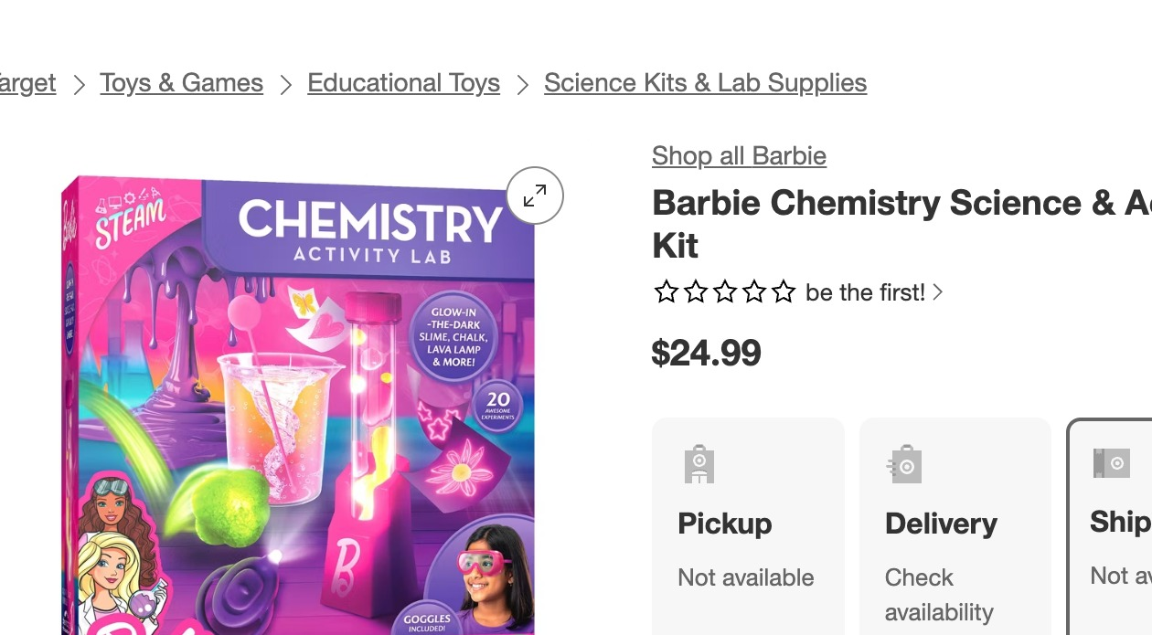
Figure 3. Barbie Chemistry Science & Activity Kit combines feminine branding with a STEM chemistry activity.
Source: Target — Barbie Chemistry Science & Activity Kit
The overall tenor is of tension between structure and agency in Target. A feminist and conflict theory lens examine who wins when gender is used as a basis for market niches; structure-versus-agency reminds us that consumers can accept, negotiate and resist those categories. Access and representation could also be analyzed along lines of class and race, but I didn't measure those dimensions in my observation. As Shopping is one of the daily spaces of everyday life, it is a space in which gender is reproduced, contested, and changed.
Reference: Coyle, E. F., & Liben, L. S. (2020). Gendered Packaging of a STEM Toy Influences Children’s Play, Mechanical Learning, and Mothers’ Play Guidance. Child Development, 91(1), 43–62. https://doi.org/10.1111/cdev.13139

